Kit Bundles - 2015
Provided by England Rugby league kit partner, BLK, we are able to offer the following kit bundles:
Basic Bundle – Junior and Senior sizes - £30
1 x Training Top
1 x Match Day Polo Shirt

Big Bundle – Junior sizes £39, Senior Sizes £43
1 x Training Top
1 x Match Day Polo Shirt
1 x Training shorts

Compared to buying directly from the website and with delivery, the junior bundles represent a saving around £5 and the senior sizes, a saving of around £10! More Cramlington Rockets kit for players and supporters is available at: www.rugbygear.co.uk > online shops > Rugby Club Shops

Free kit eligibility
Players eligible for a free kit bundle are:
- Players new to the club setting up a standing order and paying the £30/39/43. For this you will receive three months FREE subs
- Players starting a standing order that have not received any free kit in 2014 and pay the £30/39/43. For this you will receive three months FREE subs. Please note it is possible to start a standing order immediately but there will be no kit provided
- Players who have started a standing order in late 2014 and not received free kit yet
Existing players currently paying standing orders who received free kit in 2014 have the option of buying either bundle. There are no changes to the payment method and no free subs.
Tops
Size |  | J10 | J12 | J14 | J16 | XS | S | M | L | X  Large | 2X  Large | 3X  Large | 5X  Large
Chest (inches) |  | 26.-28.5 | 28.5-31 | 31-31.5 | 33.5-36 | 36-38 | 38-40 | 40-42 | 42-44 | 44-46 | 46-48 | 48-50 | 52-54
Shorts/Pants
Size | J10 |  | J12 | J14 | J16 | XS | S | M | L | X  Large | 2X  Large | 3X  Large | 5X  Large
Waist (inches) | 23.5-25 |  | 25-26.5 | 26.5-28 | 28-30 | 30-32 | 32-34 | 34-36 | 36-38 | 38-40 | 40-42 | 42-44 | 46-48

All kit comes embroidered with the Cramlington Rockets new club badge
Training top

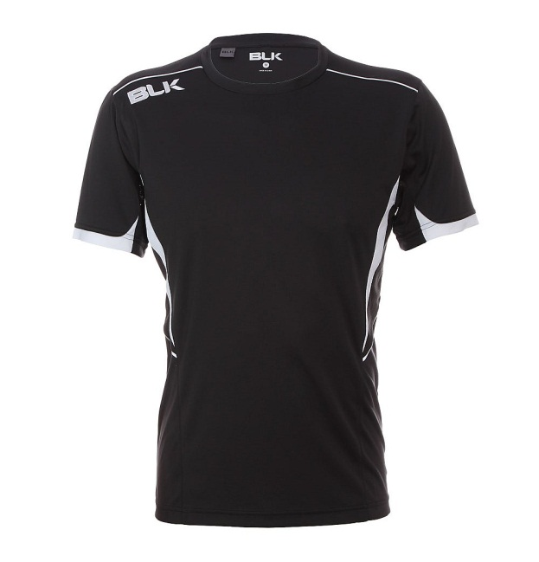
Match Day Polo Shirt
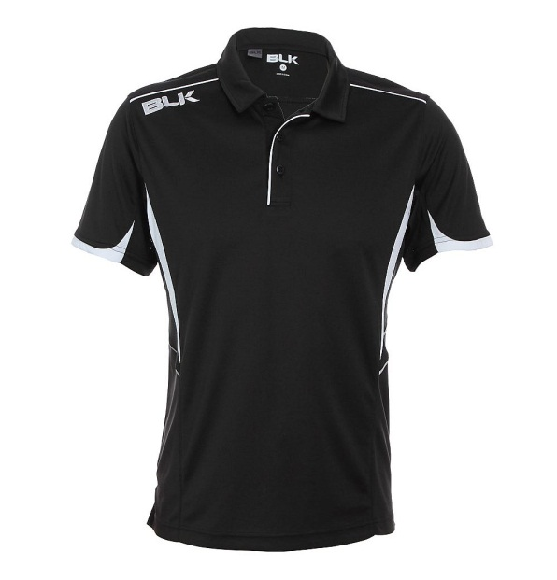
Training Shorts
