Magic Weekend 2016 - Exclusive Ticket Offers with Cramlington Rockets

Join the Orange 500 to save up to 50% and get free tickets if you buy through the club.
The 21st & 22nd May sees Magic Weekend return to Newcastle!
All 12 Super League sides will play at St James’ Park across the two days with Newcastle Thunder playing York Knights in a Friday night curtain raiser at Kingston Park for ‘Magic Friday 2’ on 20th May.
Cramlington Rockets can offer fantastic savings on tickets as the North East’s biggest rugby league club looks to sell at least 500 tickets like last time, which drew national praise.
THE ULTIMATE MAGIC WEEKEND TICKET
Our Ultimate Magic Weekend Ticket offers seating in the pitchside East Stand (Blue Unreserved) for the WHOLE weekend and a FREE ticket for Magic Friday 2 for only £40 for adults and £20 for concessions.
For those that can make only the Saturday or the Sunday, the same deal costs only £26 for adults and £15 for concessions, again in the East Stand with a FREE Magic Friday 2 ticket.
We expect demand to be high in the East and Milburn stands and could potentially sell out in February. Full payment is required with ordering.
MAGIC WEEKEND AMBASSADORS
For schools and the workplace, if anyone that sells 20 tickets to anyone not directly affiliated with a registered Rockets player, they will receive one FREE adult Ultimate Magic Weekend Ticket.
MAGICWEAR
After capturing the imagination of the visiting fans and the Sky Sports cameras with our orange t-shirts, we will be announcing a special Magic Pack of a t-shirt and wig/hat/hair fascinator for only £10 so you too can join the Orange 500. Watch cramlingtonrockets.co.uk for more info soon.
HOW TO BOOK YOUR TICKETS
Email cramlingtonrockets@gmail.com stating:
- Number of tickets for A) adults and B) concessions
- Seating area in stadium (Blue unreserved is the default area if not stated and where we sat in 2015)
- If a day ticket, if it is for Saturday or Sunday
- Please indicate if you would be interested in being a Magic Weekend ambassador, buying some Magicwear or NOT taking your FREE Magic Friday 2 ticket.
PAYMENT
Payment can be made by cash, cheque (made payable to Cramlington Rockets RLFC) or by bank transfer to Sort Code: 20 23 81 Account Number: 33431967. Use reference “MW [Your Name]” and email cramlingtonrockets.com to confirm payment has been made. Payment must be in full.

FIXTURES
Friday May 20 – Magic Friday 2 – Kingston Press Championship 1
20:00 – Newcastle Thunder v York Knights
Saturday May 21 – Magic Weekend – First Utility Super League
14.30 – Salford Red Devils v Widnes Vikings
16.45 – Warrington Wolves v Castleford Tigers
19.00 – Leeds Rhinos v Wigan Warriors
Sunday May 22 – Magic Weekend – First Utility Super League
13.00 – Wakefield Wildcats v Catalans Dragons
15.15 – St Helens v Huddersfield Giants
17.30 – Hull FC v Hull KR
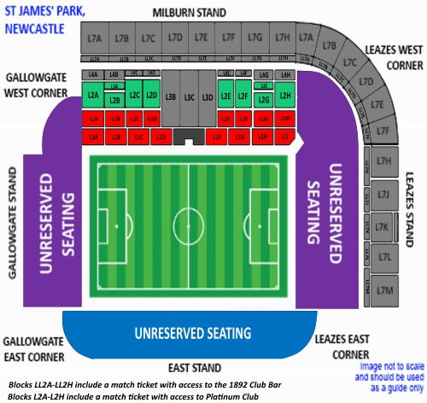
 | Reserved Stands |  |  |  | Unreserved Stands |  | Unreserved Stands
£ | Platinum Seating |  | Milburn Stand |  | East Stand |  | Leazes/Gallowgate
One day ticket | Adult | Concession | Adult | Concession | Adult | Concession | Adult | Concession
Full Price | 55 | 27.5 | 48 | 24 | 38 | 19 | 25 | 12.5
Rockets’ Price | 36 | 25 | 30 | 20 | 26 | 15 | 20 | 10
Weekend ticket | Adult | Concession | Adult | Concession | Adult | Concession | Adult | Concession
Full Price | 80 | 40 | 72 | 36 | 56 | 28 | 40 | 20
Rockets’ Price | 60 | 30 | 50 | 25 | 40 | 20 | 30 | 15
All tickets will generate £5 cashback for the club. Unreserved East Stand is the aforementioned Ultimate Magic Weekend Ticket. All tickets come with a FREE Magic Friday 2 ticket. For more info email cramlingtonrockets@gmail.com.

