Silver Package
£28 Adult
£26 Kids
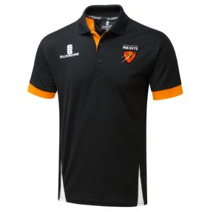
Polo
Training Top
PACKAGE - Delete as appropriate: Gold / Silver | Size |  |  |  |  |  |  |  |  | Quantity | Cost
Size | SB | MB | LB | XLB | SMALL | MED | LARGE | XL | XXL
Inches
Player name:……………………………… Age Group:……………………………….
Payment method Cash / cheque / bank transfer Notes:……………………………..
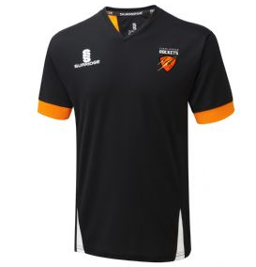
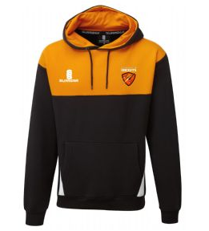
Polo
Training Top
Hoodie
£47 Adult – Saving £5
£43 Kids – Saving £5
Gold Package

