MAGIC WEEKEND 2016

MAGICWEAR

Last year, 100 Rockets turned the South East corner of St James’ Park orange, attracting the attention of the national media and Super League fans alike. This year we want even more people to make it more orange!

**Children’s T-shirts are £8, adult T-shirts are £10 and all come with a FREE Rockets sun visor. Additional visors are available for only £3 each.**

Fill in the below form and hand in to your team manager or U14s Mam, Tracey Peggie with payment in cash, cheque (payable to Cramlington Rockets RLFC) or make a bank transfer. Email cramlingtonrockets@gmail.com for details.

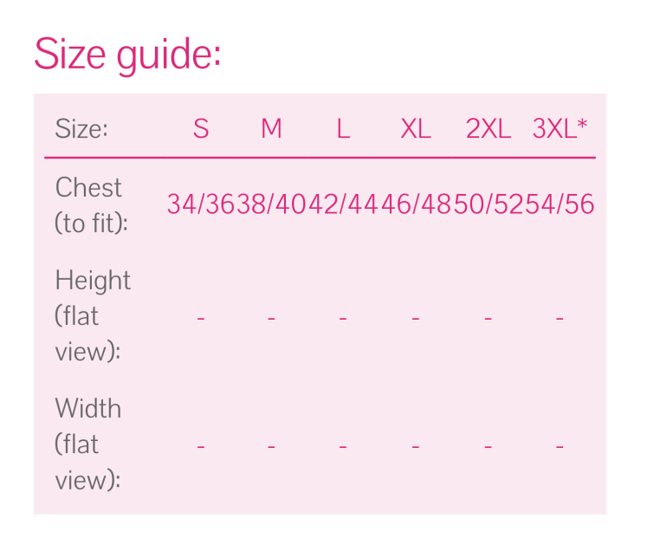

Adults

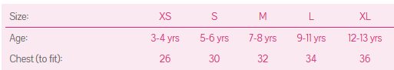Kids

|  |  |  |  |  |
| --- | --- | --- | --- | --- |
| Quantity | T-shirts/visors | Size(s) | Total | Cost |
|  |  |  |  |  |
|  |  |  |  |  |
|  |  |  |  |  |
|  |  |  |  |  |
|  |  |  |  |  |

Bank transfer to Sort Code: 20 23 81 Account Number: 33431967. Use reference “MW [Your Name]” and email cramlingtonrockets.com to confirm payment has been made. Payment must be in full. Cheques made payable to Cramlington Rockets RLFC.

