Save up to 60% on select tickets if you buy through Cramlington Rockets
All 12 Super League sides will play at St James’ Park across the two days with Newcastle Thunder playing York Knights in a Friday night curtain raiser at Kingston Park for ‘Magic Friday 3’ on 19th May.
Cramlington Rockets can offer fantastic savings on tickets as the North East’s biggest rugby league club. Over the last two years we have sold over 1,000 tickets to this not-to-be-missed event.
Our Ultimate Magic Weekend Ticket offers seating in the pitchside East Stand (Blue Unreserved) for the WHOLE weekend and a FREE ticket for Magic Friday 3 for only £36 for adults and £20 for concessions.
For those that can make one day (Saturday or the Sunday), the same deal costs only £26 for adults and £15 for concessions, again in the East Stand with a FREE Magic Friday 3 ticket.
We expect demand to be high in the East and Milburn stands and could potentially sell out in March. A £10 deposit per ticket is required when ordering and the full balance is due by 31/03/2016.
MAGIC WEEKEND AMBASSADORS
For schools and the workplace, if anyone that sells TEN tickets to anyone non-registered Rockets player, they will receive one FREE adult Ultimate Magic Weekend Ticket.
MAGICWEAR
Our famous orange t-shirts will be returning! Watch cramlingtonrockets.co.uk for more info soon.
FIXTURES
Friday May 19 – Magic Friday 3 – Kingston Press League 1 @ Kingston Park Stadium
20:00 – Newcastle Thunder v York Knights
Saturday May 20 – Magic Weekend – First Utility Super League
14.30 – Widnes Vikings vs Wakefield Trinity
16.45 – Hull FC vs St Helens
19.00 – Wigan Warriors vs Warrington Wolves
Sunday May 21 – Magic Weekend – First Utility Super League
13.00 – Catalan Dragons vs Huddersfield Giants
15.15 – Leigh Centurions vs Salford Red Devils
17.30 – Castleford Tigers vs Leeds Rhinos
HOW TO BOOK YOUR TICKETS
Complete the order form overleaf and return to team managers or cramlingtonrockets@gmail.com.
PAYMENT
Payment can be made by cash, cheque (made payable to Cramlington Rockets RLFC) or by bank transfer to Sort Code: 20 23 81 Account Number: 33431967. Use reference “MW [Your Name]” and email cramlingtonrockets.com to confirm payment has been made. A £10 DEPOSIT PER TICKET IS REQUIRED WHEN ORDERING AND THE FULL BALANCE IS DUE BY 31/03/2016.
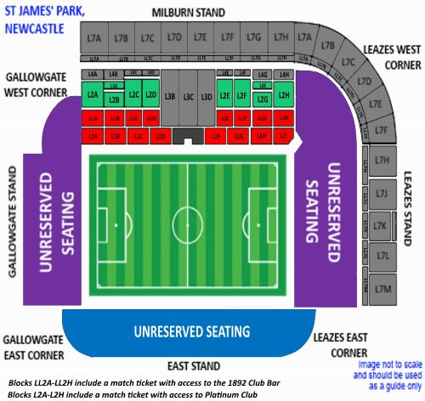
 | Reserved Stands |  |  |  | Unreserved Stands |  | Unreserved Stands
PRICES | Platinum Seating |  | Milburn Stand |  | East Stand |  | Leazes/Gallowgate
Weekend ticket | Adult | Concession | Adult | Concession | Adult | Concession | Adult | Concession
Full Price | 80 | 40 | 72 | 36 | 56 | 28 | 40 | 20
Rockets’ Price | 52 | 26 | 46 | 23 | 36 | 20 | 26 | 15
Saturday or Sunday ticket | Adult | Concession | Adult | Concession | Adult | Concession | Adult | Concession
Full Price | 55 | 27.50 | 48 | 24 | 38 | 19 | 25 | 12.50
Rockets’ Price | 36 | 20 | 31 | 18 | 26 | 15 | 20 | 11
All tickets generate approximately £5 cashback for the club and come with a FREE Magic Friday 3 ticket. For more info: cramlingtonrockets@gmail.com. East Stand Blue is default ‘ultimate ticket’
--------------------------------------------------------------------------------------------------------------------------------------
ORDER FORM – Please complete, detach and return to the club. BLUE EAST SECTION is Default ticket
Area - Green/ red/ blue/purple | Stand (if applicable) | Day / weekend | No. Of tickets - ADULT |  | No. Of tickets - CONCESSION |  | Sub-total | Total
Plus £1 processing & delivery fee |  |  |  |  |  |  |  | £1
Payment Method – delete as appropriate – details overleaf  Cash / cheque / bank transfer |  |  |  |  |  | Total
Name |  |  |  | Contact number
Age Group (if applicable) |  |  |  | Email
Address

