Sell TEN tickets, receive one free
All 12 Super League sides will play at St James’ Park across the two days with Newcastle Thunder playing York Knights in a Friday night curtain raiser at Kingston Park for ‘Magic Friday 3’ on 19th May.
We are offering members of the Rockets Family to attend the event for free by promoting it to their friends, family and colleagues.
How it works
- Sell Magic Weekend Tickets to ten different individuals and we will give you an Ultimate Magic Weekend ticket for FREE. Single day or purple area tickets are also options.
- Simply print off the poster on our website and hang it up, inserting your contact details in the space provided.
- You can either be the point of contact for all your friends and hand out the tickets to save on the £1 processing fee or let us distribute them.
- Make sure we have the right details on the order form and return to Team Managers, organiser Richard Robinson (U16s Coach) or email to cramlingtonrockets@gmail.com.
What is an Ultimate Magic Weekend Ticket?
Our Ultimate Magic Weekend Ticket offers seating in the pitchside East Stand (Blue Unreserved) for the WHOLE weekend and a FREE ticket for Magic Friday 3 for only £36 for adults and £20 for concessions.
For those that can make one day (Saturday or the Sunday), the same deal costs only £26 for adults and £15 for concessions, again in the East Stand with a FREE Magic Friday 3 ticket. We expect demand to be high in the East and Milburn stands and could potentially sell out in March. A £10 deposit per ticket is required when ordering and the full balance is due by 31/03/2016.
FIXTURES
Friday May 19 – Magic Friday 3 – Kingston Press League 1 @ Kingston Park Stadium
20:00 – Newcastle Thunder v York Knights
Saturday May 20 – Magic Weekend – First Utility Super League
14.30 – Widnes Vikings vs Wakefield Trinity
16.45 – Hull FC vs St Helens
19.00 – Wigan Warriors vs Warrington Wolves
Sunday May 21 – Magic Weekend – First Utility Super League
13.00 – Catalan Dragons vs Huddersfield Giants
15.15 – Leigh Centurions vs Salford Red Devils
17.30 – Castleford Tigers vs Leeds Rhinos
PAYMENT
Payment can be made by cash, cheque (made payable to Cramlington Rockets RLFC) or by bank transfer to Sort Code: 20 23 81 Account Number: 33431967. Use reference “MW [Your Name]” and email cramlingtonrockets.com to confirm payment has been made. A £10 DEPOSIT PER TICKET IS REQUIRED WHEN ORDERING AND THE FULL BALANCE IS DUE BY 31/03/2016.
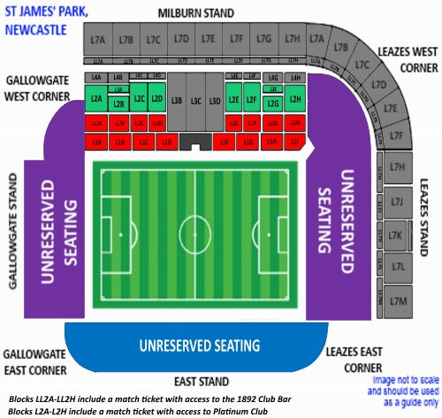
 | Reserved Stands |  |  |  | Unreserved Stands |  | Unreserved Stands
PRICES | Platinum Seating |  | Milburn Stand |  | East Stand |  | Leazes/Gallowgate
Weekend ticket | Adult | Concession | Adult | Concession | Adult | Concession | Adult | Concession
Full Price | 80 | 40 | 72 | 36 | 56 | 28 | 40 | 20
Rockets’ Price | 52 | 26 | 46 | 23 | 36 | 20 | 26 | 15
Saturday or Sunday ticket | Adult | Concession | Adult | Concession | Adult | Concession | Adult | Concession
Full Price | 55 | 27.50 | 48 | 24 | 38 | 19 | 25 | 12.50
Rockets’ Price | 36 | 20 | 31 | 18 | 26 | 15 | 20 | 11
All tickets generate approximately £5 cashback for the club and come with a FREE Magic Friday 3 ticket. For more info: cramlingtonrockets@gmail.com. East Stand Blue is default ‘ultimate ticket’
--------------------------------------------------------------------------------------------------------------------------------------
ORDER FORM – Please complete, detach and return to the club. BLUE EAST SECTION is Default ticket
Area - Green/ red/ blue/purple | Stand (if applicable) | Day / weekend | No. Of tickets - ADULT |  | No. Of tickets - CONCESSION |  | Sub-total | Total
Plus £1 processing & delivery fee |  |  |  |  |  |  |  | £1
Payment Method – delete as appropriate – details overleaf  Cash / cheque / bank transfer |  |  |  |  |  | Total
Name |  |  |  | Contact number
Age Group (if applicable) |  |  |  | Email
Address

