MAGIC WEEKEND 2017 EVENT T-SHIRT
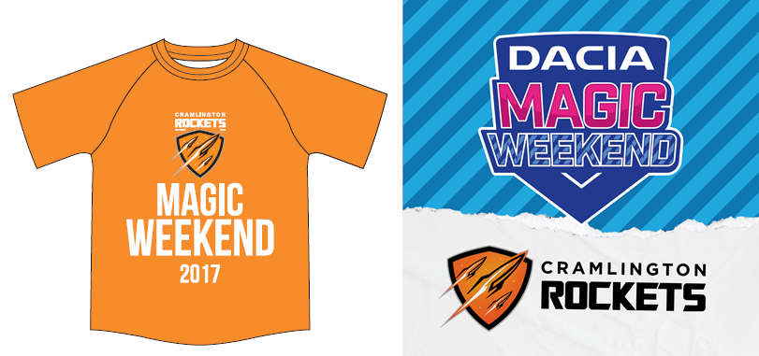
T-Shirts are £5 for children, £7 for adults
Fill in the below form and hand in to your team manager or U16s Mum, Tracey Peggie with payment in cash, cheque or make a bank transfer by 27th April. T-shirts will be distributed at training at Cramlington from 10th May.
MALE SIZING
Size: | S | M | L | XL | XXL | 3XL | 4XL | 5XL
Chest (to fit): | 35/37 | 38/40 | 41/43 | 44/46 | 47/49 | 50/52 | 53/55 | 56/58
FEMALE SIZING
Size: | XS | S | M | L | XL | XXL
Ladies size: | 8 | 10 | 12 | 14 | 16 | 18
Chest (to fit): | 30 | 32 | 34 | 36 | 38 | 40
KIDS SIZING
Age: | 3-4 | 5-6 | 7-8 | 9-11 | 12-13 | 14-15
Height (cm): | 104 | 116 | 128 | 140 | 152 | 164
Chest (to fit): | 22/24 | 26/28 | 30 | 32 | 34 | 36

Quantity | Male/Female/Youth | Size(s) | Total | Cost
Name & contact No. |  | Age Group | TOTAL
Bank transfer to Sort Code: 20 23 81 Account Number: 33431967. Use reference “MT [Your Name]” and email cramlingtonrockets.com to confirm payment in full.
Cheques made payable to Cramlington Rockets RLFC.

