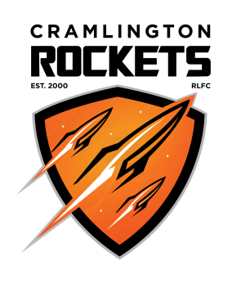
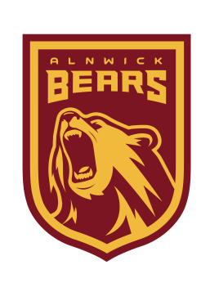
VOTE FOR US to transform your community

New community club needs your help!

Alnwick Bears RLFC is launching in 2018, supported by RFL Club of the Year, Cramlington Rockets.
Please spare two minute to vote for us to win £25,000 to transform your local community using sport.

Visit: www.avivacommunityfund.co.uk
Search: Get Northumberland Rocketing! by Cramlington Rockets
Multiple votes per household are allowed!

www.pitchero.com/clubs/alnwickbearsrlfc

