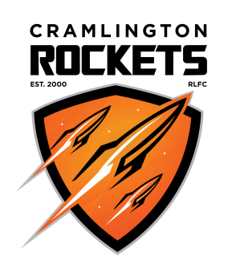
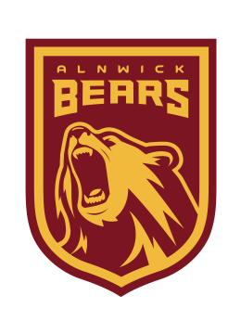
VOTE FOR US to transform our community

Community club, Cramlington Rockets needs your help!

Please vote for us to win £25,000 to transform our local community using sport.
Visit: www.avivacommunityfund.co.uk
Search: Get Northumberland Rocketing! by Cramlington Rockets
Multiple votes per household are allowed!

www.cramlingtonrockets.co.uk

