PLEASE NOTE: YOU ARE ONLY A NEW PLAYER IF YOU HAVE NEVER PLAYED RUGBY LEAGUE FOR A CLUB OR A TEAM AT ANY AGE GROUP.
- You will need a link in order to register for the club. This can be sent to you, but it is also shown here:
https://reg.sportingpulse.com/regoform.cgi?aID=25795&pKey=9d550ce53736bee706a1023b5921ae65&formID=64495
- Click on the link and you will see the following page:
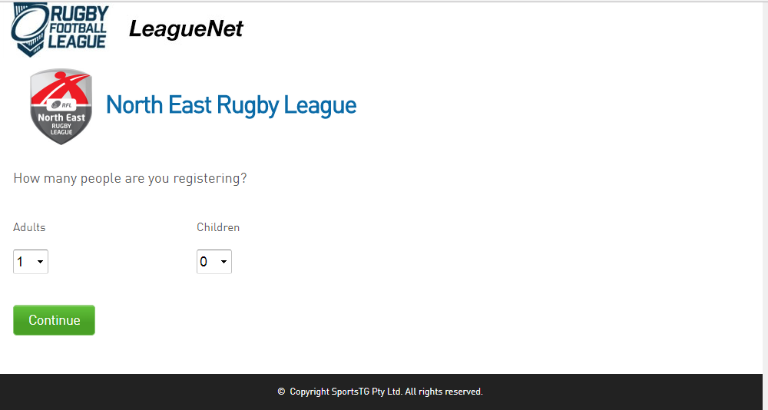
- Complete the boxes as necessary: either for yourself or for children and then click continue. The following screen appears

Continued on next page
- Enter your email address and click <continue>. The following screen should appear
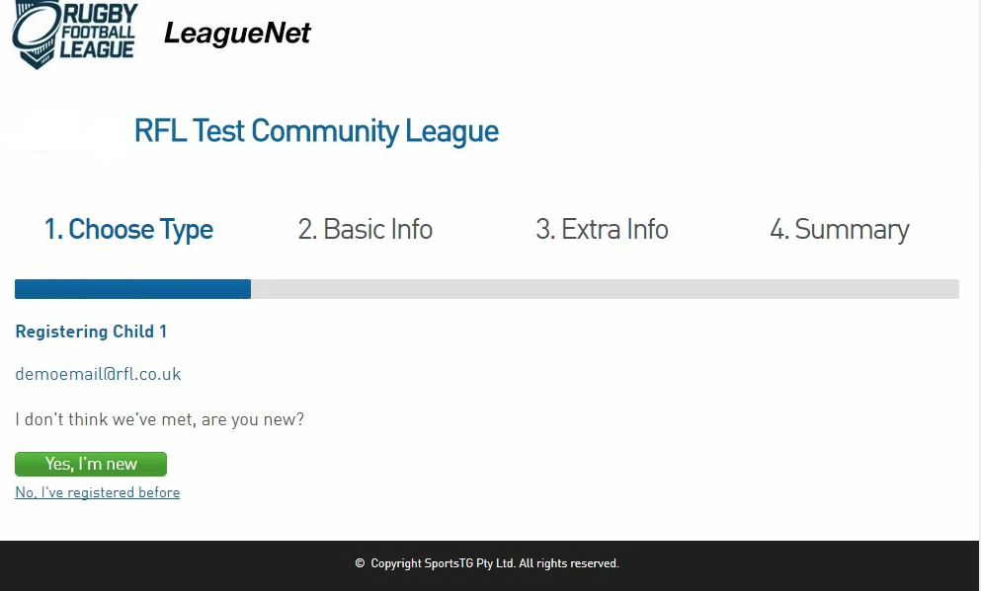
- If you do not see this screen, then it is probable that you are ‘in the system’. If that is the case, then contact me (jansuro’sky.com).
- When you see this screen, then you will click on ‘Yes. I’m New’
- An email will be sent to the address you entered in step 3. The link in the email will only be valid for one hour.
- Click to set password in the email and you will be taken to a page to set a password
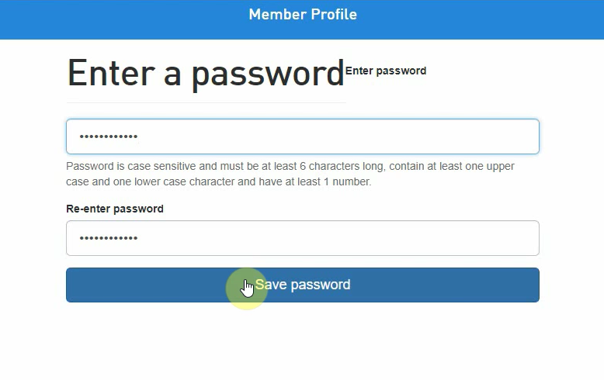
- You will need to enter your password twice. Remember to save password.
- You will then see this screen
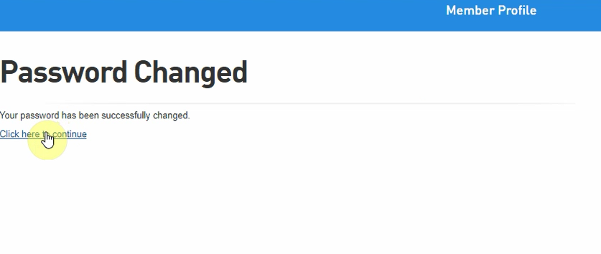

- Click on the link to continue to the next screen

Continued on nest page
- Select the club you want to join from the drop-down list
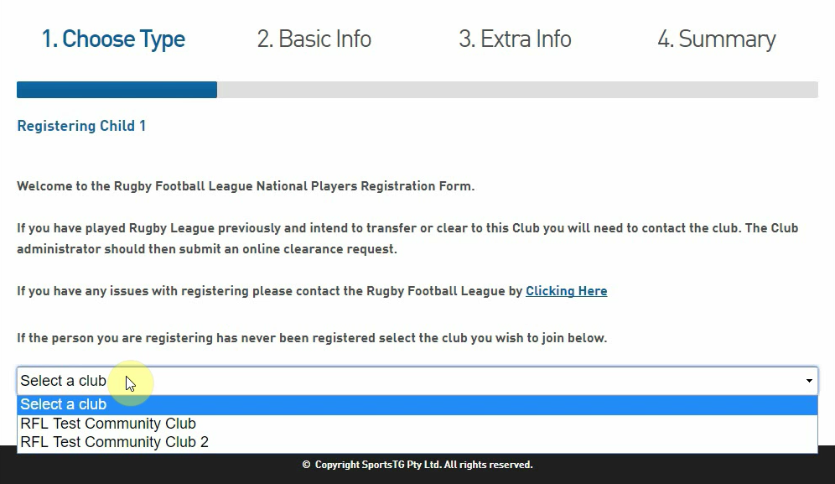

- A fresh screen appears which asks you to fill in some basic information
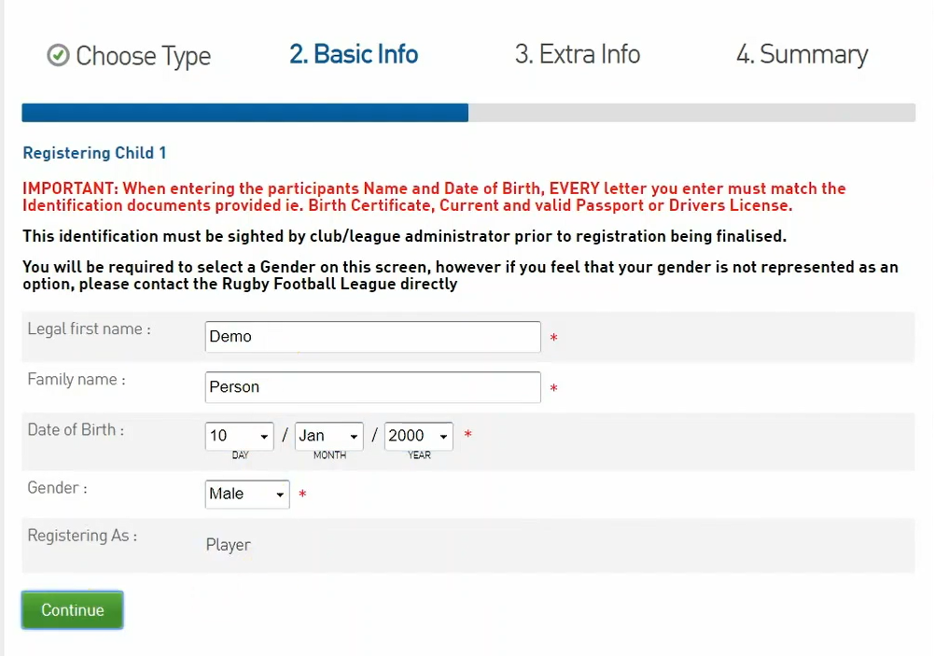
- PLEASE NOTE: You only need to complete the sections marked with a red asterisk. The section on documents is only relevant if you are registering a child.
- A new screen will appear asking for some more information
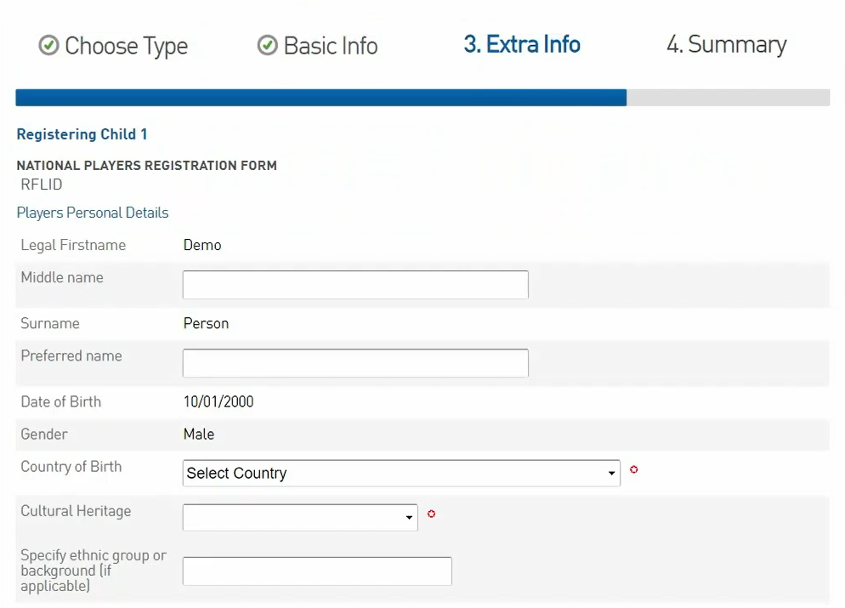

- You will need to tick a box to say that you agree to terms and conditions
- Remember to click confirm. This will take you to a new screen
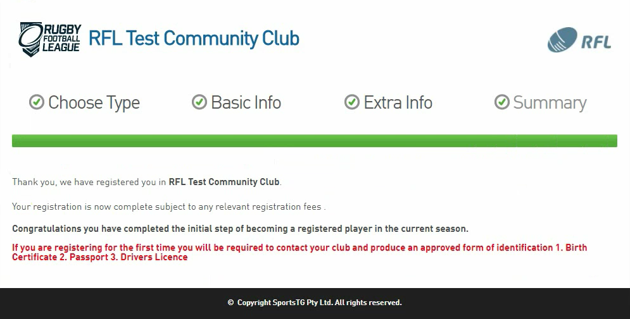

- Your registration is now ‘pending approval’ by the club and the league.
- You will receive an email from the club or the league confirming your membership.

